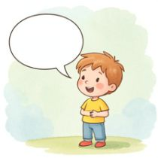 | Fill in the Gaps: Making a Complaint  ​  A complaint is when we tell someone that something is not right so they can fix it. Read the letters below and fill in the missing words from the word banks!
​
1. The Empty Chocolate Bar
​

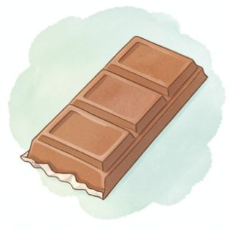 | ​  Dear Shopkeeper,  ​  I bought a yummy treat but when I opened it, it was 1. __________ !  ​  This is a 2. __________ because I really wanted a snack.  ​  I would like a new chocolate bar. This is the 3. __________ .  ​  Thank you for helping. I am using a 4. __________ voice.  ​  From, Sam
  Word Bank: empty | problem | outcome | polite
​
Write the missing words here:
​

1.  ​ | 2.  ​
3.  ​ | 4.  ​
​

Word Bank: reason | fresh | soggy | kind
​  Dear Cafe,  ​  My food is not right. The bread on my sandwich is very 1. __________ !  ​  The 2. __________ this happened is because the tomato leaked through.  ​  Please can I have a 3. __________ sandwich instead?  ​  Thank you for your help. I am being very 4. __________ and respectful.  ​  From, Ben | 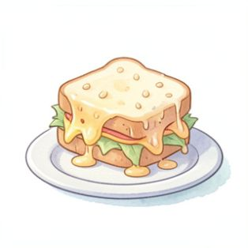
1.  ​ | 2.  ​
3.  ​ | 4.  ​
2. The Soggy Sandwich

Write the missing words here:
​

