Writing a Complaint
​

A complaint has three important parts:
​
1. The problem (what went wrong).
​
2. The reason (why it is a problem).
​
3. The desired outcome (what you want them to do to fix it).
​

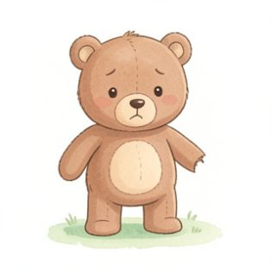 | Tim bought a new teddy bear from the toy shop. When he opened the box, the bear's arm was missing! Tim is very sad because he cannot play with a broken toy. He wants the shop to send him a brand new teddy bear.  ​  1. What is the problem?  ​
​
2. Why is this a problem?
​

​
3. What does Tim want the shop to do?
​

​
Your Turn!
​

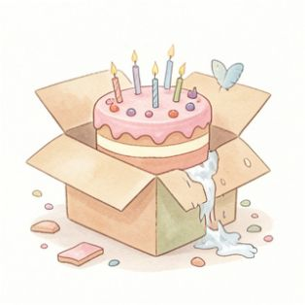 | You ordered a birthday cake, but the delivery driver dropped it! The cake is completely squashed.  ​  Write a polite complaint letter to the bakery. Remember to include the problem, the reason, and what you want them to do.

