Industrial Revolution Research
​

📢​ | Use books, encyclopaedias, or safe internet searches to find fascinating facts about the Industrial Revolution and the Victorians. Write your findings in the spaces below.
​
1. Marvellous Machines and Inventions
​

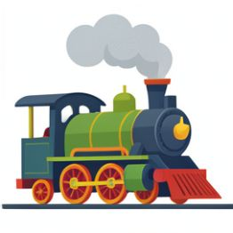 | The Industrial Revolution changed how things were made. Find out about two important inventions from this time. What were they, who invented them, and how did they change the world?  ​
​
2. Children at Work
​

Life was very tough for many Victorian children. Research what it was like for a child working in a factory, a coal mine, or as a chimney sweep. What jobs did they do, and how long did they work?  ​ | 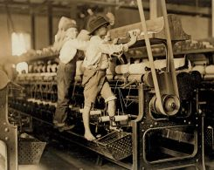
​

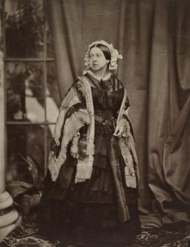 | Who was Queen Victoria, and how long did she rule? Then, find one other famous person from this time (for example, Isambard Kingdom Brunel, Florence Nightingale, or Dr Thomas Barnardo) and write down what they are famous for.  ​
3. Famous Faces of the Victorian Era

4. Daily Life and Towns
​

During the Industrial Revolution, lots of people moved from the countryside to the towns. Research what a typical Victorian town was like. Was it clean or dirty? What were the houses like for poor families?  ​ | 

