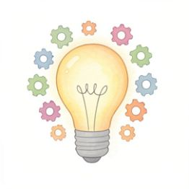 | My Great Invention!  ​  During the Industrial Revolution, people created amazing new inventions to make their work and lives easier.  ​  Now it is your turn! Think of a brand new invention that would make your life better.
​
Name of your invention:
​

​
Draw your invention here! Make sure to add lots of colourful details.
​

​
What does your invention do?
​

​
How would it make your life better?
​

